## Creating and Configuring Web Applications

**Lab Time**: 45 minutes

**Lab Folder**: C:\Student\Labs\05.WebApplications

**Lab Overview**: In the following lab, you will create and configure a Web application for the Wingtip intranet. You will also create and configure a second Web application which will be used to stand up the public Web site for Wingtip Toys.

### Exercise 1: Configuring DNS A Host Records in DNS Manager

In this exercise you will add two DNS A Records to the DNS Manager to resolve the DNS names of **intranet.wingtip.com** and **www.wingtip.com** to the IP address of **192.168.150.1**.

1. Log on to the **WingtipServer** VM.
2. Start DNS Manager from **Start » Administrative Tools » DNS**.

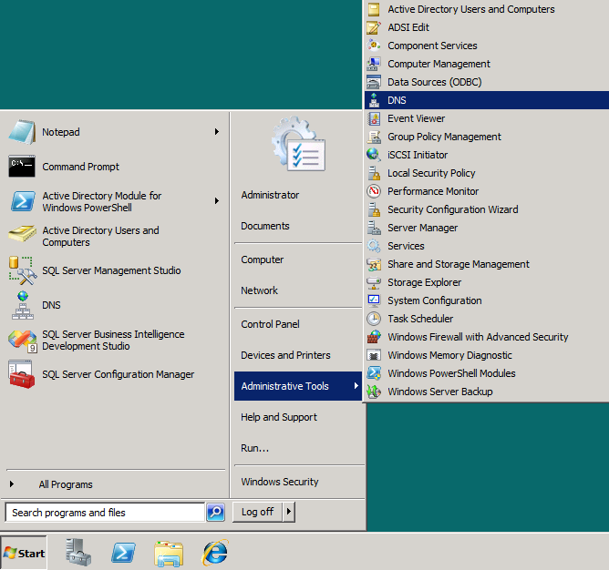

1. Create an A Host for **intranet.wingtip.com** pointing to **192.168.150.1**
   1. In the DNS Manager, navigate down the hierarchy of node to **DNS » WINGTIPSERVER » Forward Lookup Zones » wingtip.com**.

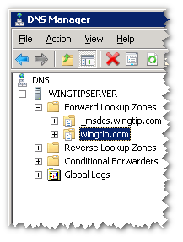

* 1. Right-click on the **wingtip.com** node and create a new A Record by click menu command with the caption of **New Host (A or AAAA)**.

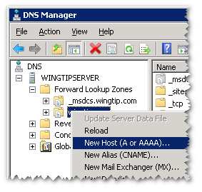

* 1. In the **New Host** dialog enter a **Name** of **intranet** and an **IP address** of **192.168.150.1**. When you are done, click the **Add Host** button to create the new A Record. Click **OK**.

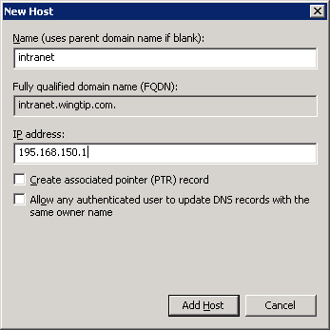

* 1. Create a second Host A Record named **www** pointing to the same IP. When the record has been created, click **Done** to exit out of the **New Host** dialog.

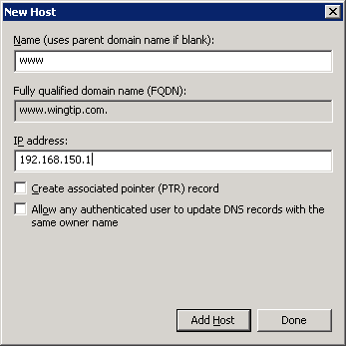

* 1. You should be able to verify that there are new DNS A records for **www** and **intranet**.

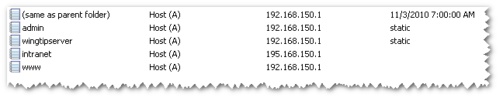

1. Now it is time to test your work. You will ensure that you can resolve the DNS names of intranet.wingtip.com and www.wingtip.com to the correct IP address.
2. Bring up a standard Windows command prompt.
   1. Ensure you can ping the DNS name of **intranet.wingtip.com** and have it resolve to the IP address of **192.168.150.1**.

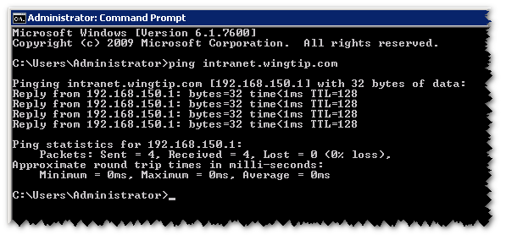

* 1. Ensure you can ping the DNS name of **www.wingtip.com** and have it resolve to the IP address of **192.168.150.1**.

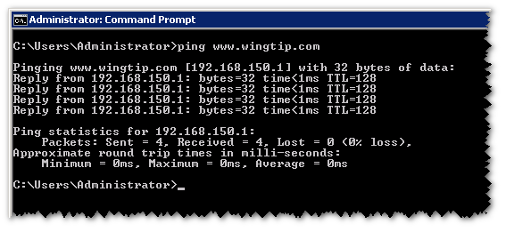

### Exercise 2: Create a new Web Application for the Wingtip Intranet

In this exercise you will create a new Web Application at **http://intranet.wingtip.com** using the classic mode authentication provider.

1. Make sure you are logged onto the **WingtipServer** VM.
2. Launch Central Administration and click the **Manage web applications** link under the **Application Management** section.

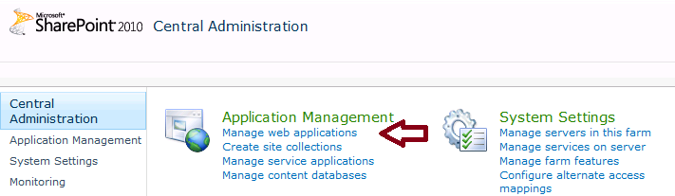

1. On the **Web Applications Management** page, click the **New** button in the top left corner of the ribbon which will bring up the **Create New Web Application** dialog.

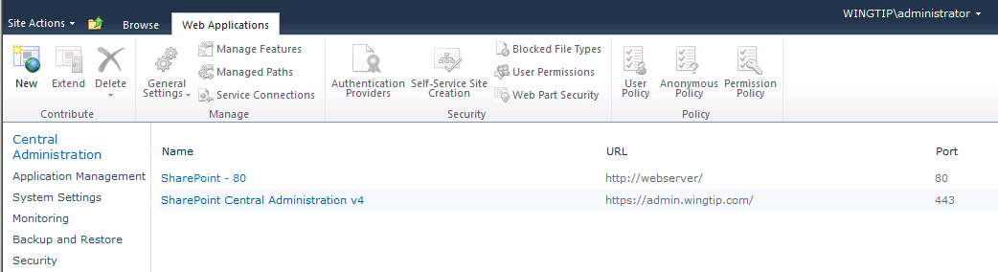

1. Select **Classic Mode Authentication**.

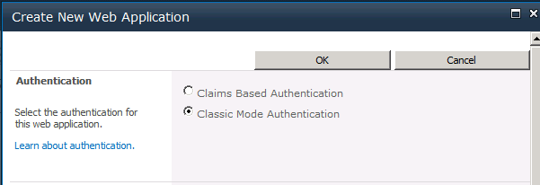

1. Move down to the **IIS Web Site** section of the **Create New Web Application** dialog. Enter a new IIS Web Site name of **Wingtip Intranet**. Change the **Port** setting at **80**. Enter a **Host Header** of **intranet.wingtip.com** and a **Path** of **C:\inetpub\WingtipIntranet**. Your settings should mirror the following screenshot.

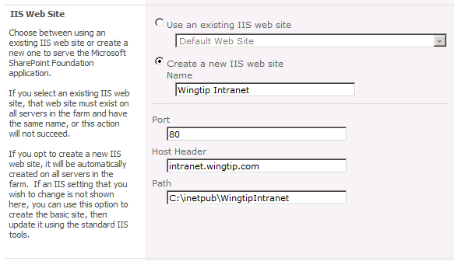

1. Move down to the **Security Configuration** section of the **Create New Web Application** dialog. You can leave the settings in this section with their default values as shown in the following screenshot.

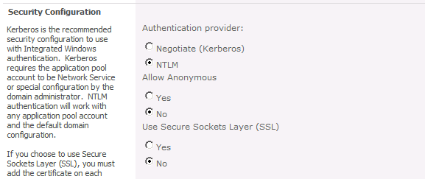

1. Move down to the **Public URL** section of the **Create New Web Application** dialog. Modify the URL by removing the port number from the end of the URLas shown in the following screenshot.

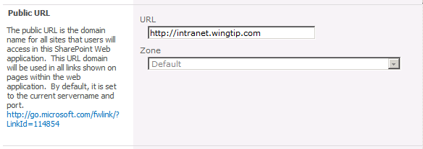

1. Move down to the **Application Pool** section and select the option for **Create new application pool**. Give it a name of **Wingtip Web Applications**. For the **Select a security account for this application pool** option, select **Configurable** and select the Managed account for **WINGTIP\sp_webapp**.

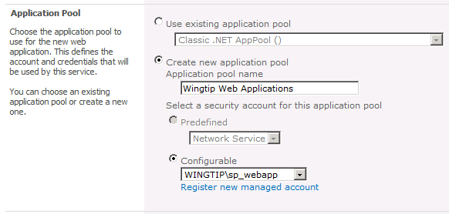

1. Move down to the **Database Name and Authentication** section of the **Create New Web Application** dialog. Make sure **Database Server** is set to **WINGTIPSERVER**. Change the **Database Name** to **WingtipIntranet_ContentDB**. Leave the **Database authentication** setting set to **Windows authentication**.

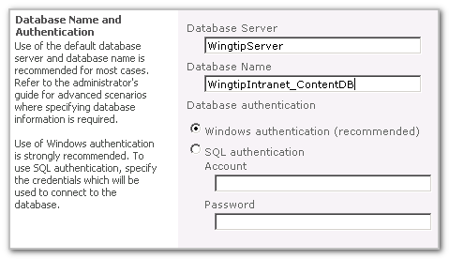

1. The next two sections are **Failover Server** and **Search Server** which you can leave in their default state.

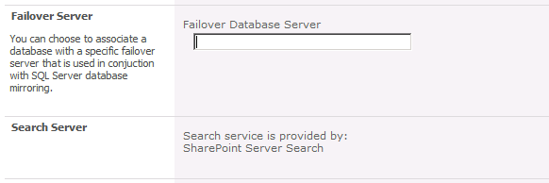

1. The next section is the **Service Application Connections** section. Leave this in its default state where it is assigned to the **default** group of service application connections.

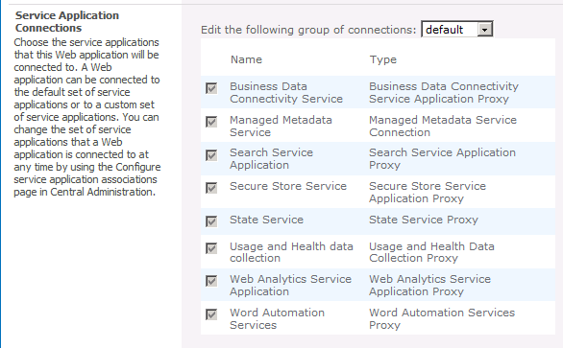

1. Now click the **OK** button to provision the new Web Application.

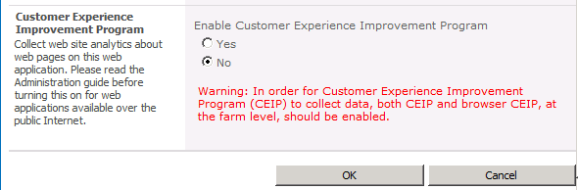

1. After the new Web application has been created, you will be prompted with the following dialog. Click the link at the bottom with the caption **Create Site Collection**.

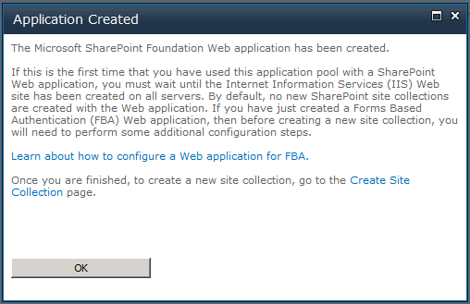

1. In the **Create Site Collection** dialog, enter a **Title** of **Wingtip Intranet**. In the **Template Selection** section, make sure **Team Site** is selected as the site template for the top-level site.

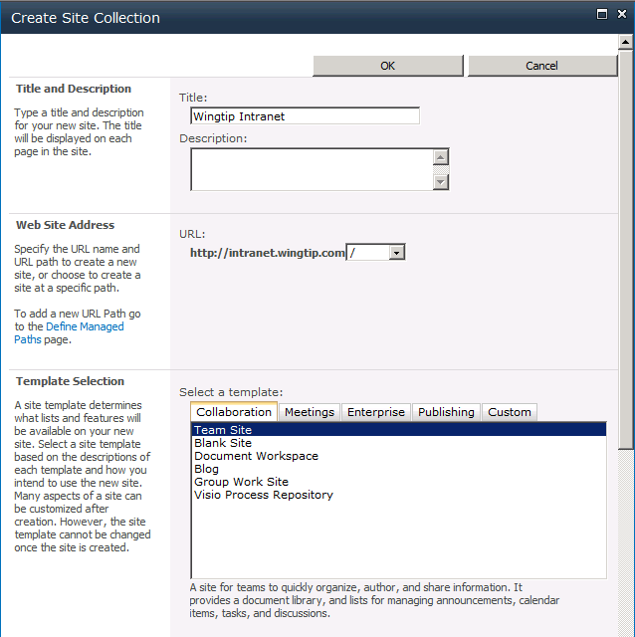

1. In the **Primary Site Collection Administrator** section enter a user name of **WINGTIP\Administrator** and then click **OK** to provision the new site collection at the root of the new Web application.

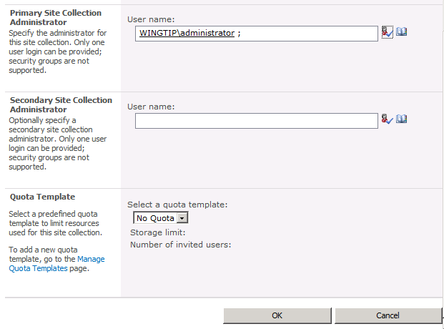

1. When the site collection has been created, you will be prompted with the following dialog. Click the link to http://intranet.wingtip.com to navigate to the new site collection.

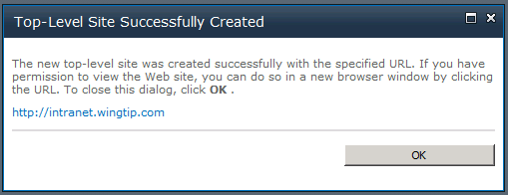

1. You should now see the new team site that has been created at the root of the new web application.

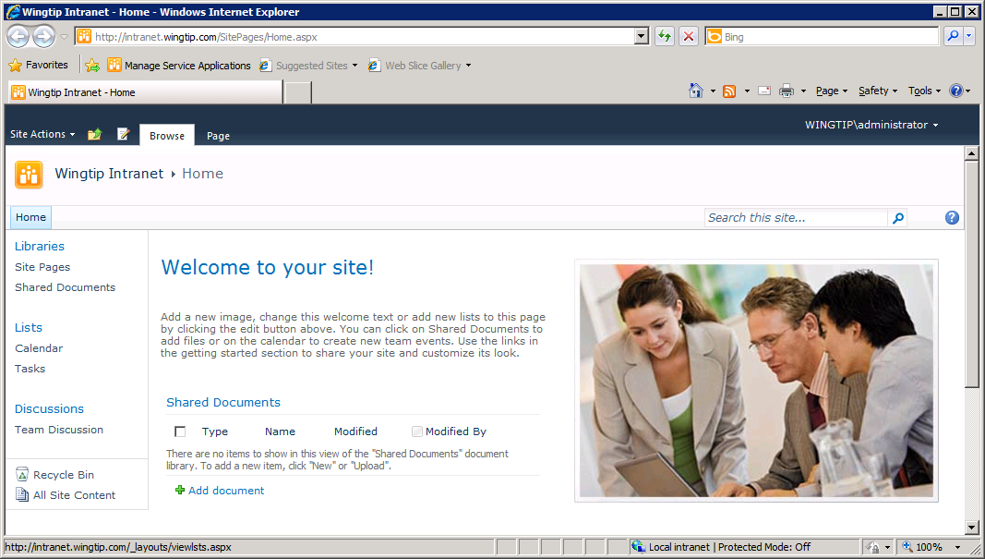

1. Now return to Central Administration and verify you can see the new web application in the **Web Applications Management** page. Take a moment and inspect **General Settings** for the new Web application.

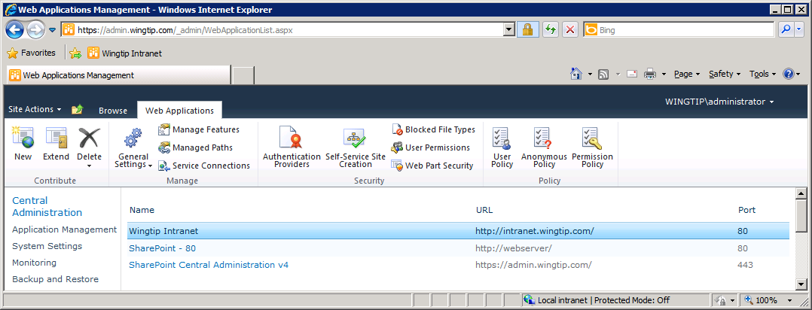

In this exercise you created a new Web Application at **http://intranet.wingtip.com** using the classic mode authentication provider.

### Exercise 3: Create a new Web Application for the Wingtip Public Web Site

In this exercise you will create a second Web application at **http://www.wingtip.com** to host the Wingtip public Web site.

1. Launch Central Administration and click the **Manage web applications** link under the **Application Management** section.



1. On the **Web Applications Management** page, click the **New** button in the top left corner which will bring up the **Create New Web Application** dialog.
2. In the **Authentication** section, select **Claim Based Authentication**.

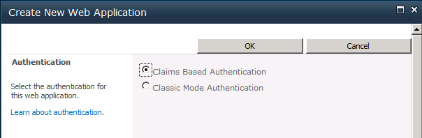

1. Move down to the **IIS Web Site** section of the Create New Web Application dialog. Enter a new IIS Web Site name of **Wingtip Public Web Site**. Change the **Port** setting at **80**. Enter a **Host Header** of **www.wingtip.com** and a **Path** of **C:\inetpub\WingtipPublicWebSite**. Your settings should mirror following screenshot.

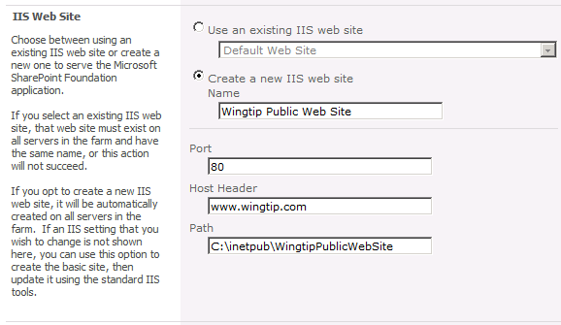

1. Move down to the **Security Configuration** section. Set the setting for **Allow Anonymous** to **Yes**.

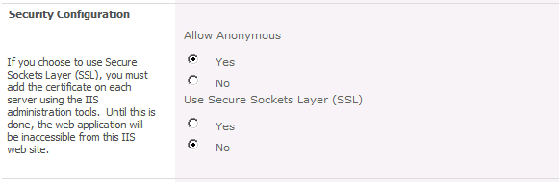

1. Move down to the **Claims Authentication Types** section and click the checkbox for **Basic Authentication** to allow Windows Authentication for users across the Internet.

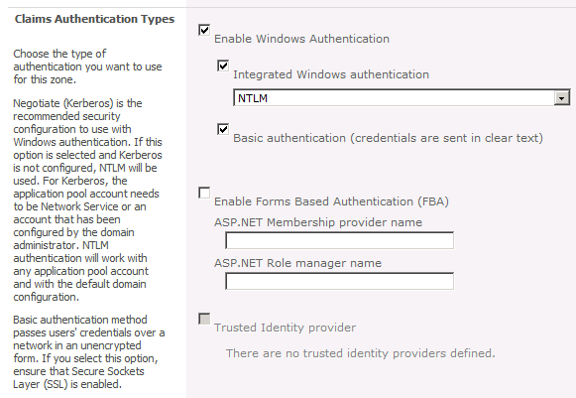

1. Move down to the **Sign In Page URL** section of the Create New Web Application dialog. You can leave default values as shown in the following screenshot.

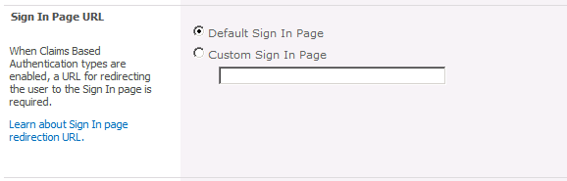

1. Move down to the **Public URL** section. Modify the URL by removing the port number from the end so the URL is **http://www.wingtip.com**.

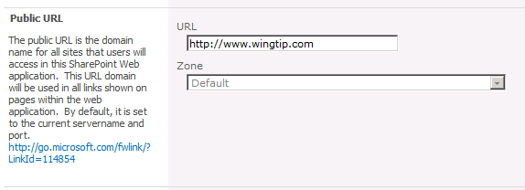

1. Move down to the **Application Pool** section. Select the option for **Use existing application pool** and select **Wingtip Web Applications**.

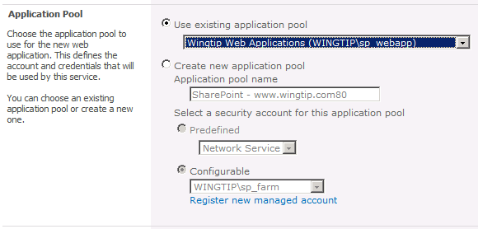

1. Move down to the **Database Name and Authentication** section. Verify the **Database Server** is set to **WingtipServer**. Change the **Database Name** to **WingtipPublicWebSite_ContentDB**. Leave the **Database authentication** setting set to **Windows authentication**.

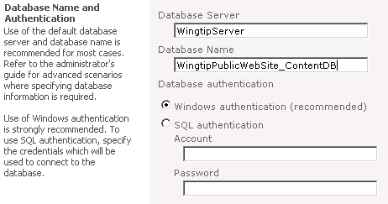

1. The next two sections are **Failover Server** and **Search Server** which you can leave in their default state.

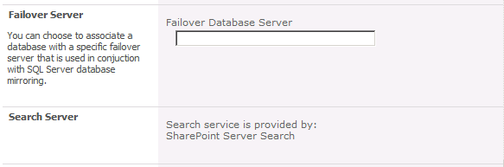

1. The next section is the **Service Application Connections** section. Change the combo box value from **default** to **custom**. Select a custom set of service application connections with the following service application connections.
2. Search Service Application
3. State Service
4. Usage and Health data collection
5. Web Analytics Service Application

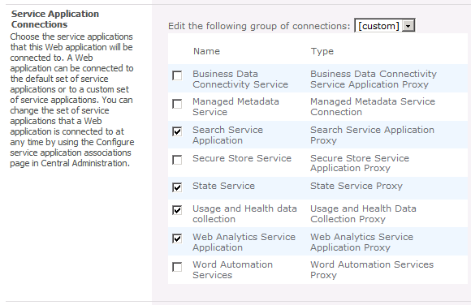

1. Click the **OK** button at the bottom of the page to begin the provisioning process for the new Web application.

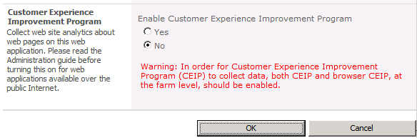

1. After the new Web application has been created, you will be promoted with the following dialog. Click the link at the bottom with the caption **Create Site Collection**.



1. In the **Create Site Collection** dialog, enter a **Title** of **Wingtip Toys**. In the **Template Selection** section, navigate to the **Publishing** tab and select **Publishing Portal** as the site template for the top-level site.

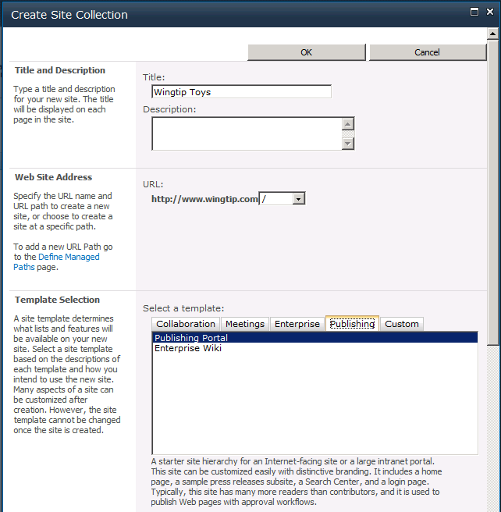

1. In the **Primary Site Collection Administrator** section enter a user name of **WINGTIP\Administrator** and then click **OK** to provision the new site collection at the root of the new Web application.



1. When the site collection has been created, you will be prompted with the following dialog. Click the link to **http://www.wingtip.com** to navigate to the new site collection.

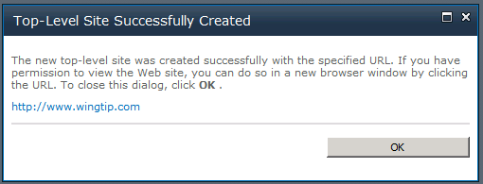

1. When prompted to log in, use the **WINGTIP\Administrator** account. This should allow you to gain access to the new publishing site that has been created at the root of the new web application.

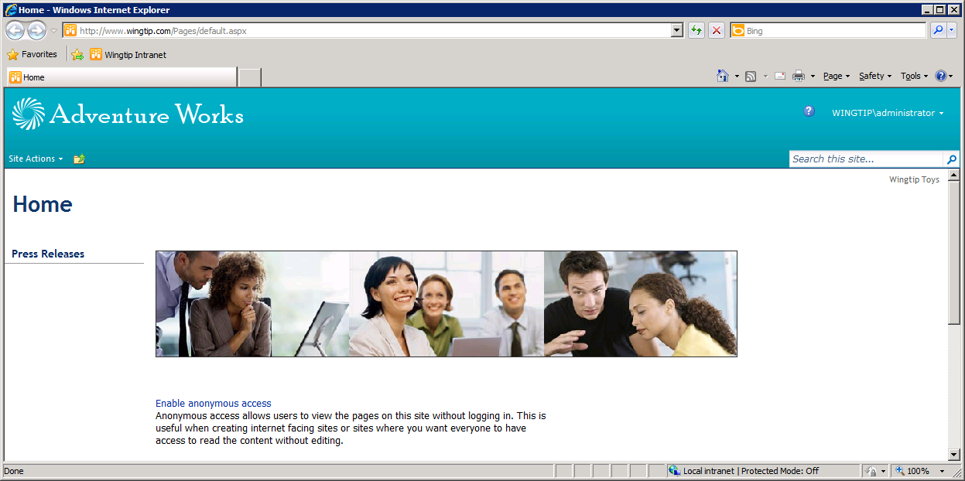

1. Now return to Central Administration and verify you can see the new web application in the **Web Applications Management** page. Take a moment and expect **General Settings** for the new Web application.

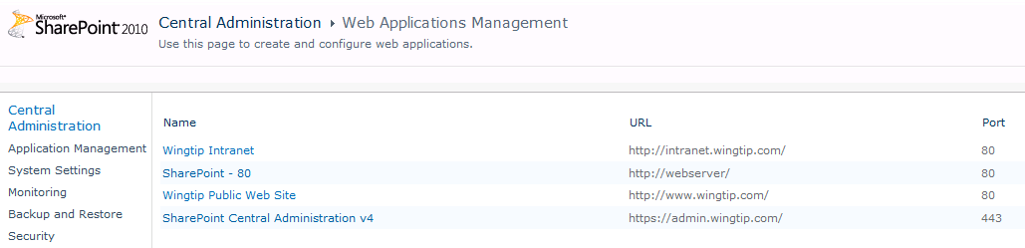

In this exercise you created a new public site using the claims authentication mode provider.

### Exercise 4: Configuring Anonymous Access for Testing

In this last exercise, you will enable anonymous access on the site collection you created in the previous exercise. You will also make some configuration changes to the Internet Explorer so that you can test how the site behaves when accessed using anonymous access.

1. Navigate to the new publishing site at http://www.wingtip.com.
2. Find the link on the home page with the caption **Enable anonymous access** and click on it. This will take you to the **Change Anonymous Access Settings** page.
3. For the **Anonymous users can access** option, select **Entire Web site**.
4. Click the **OK** button to save your changes.

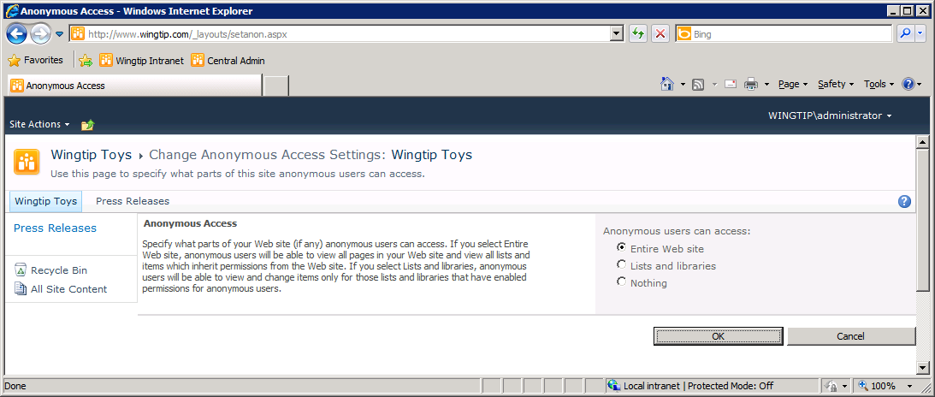

1. Close all open instances of the Internet Explorer.
2. Click **Start » Run** and type in the URL of <http://www.wingtip.com> and click **OK**.

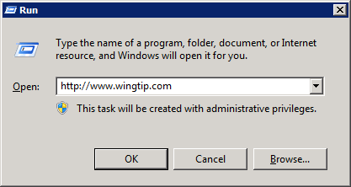

1. The Internet Explorer should now take you to the new site. You should be able to see a link with the caption of **Sign in** in the upper right corner of the page. This is an indication that the browser has been able to access the site at www.wingtip.com using anonymous access.

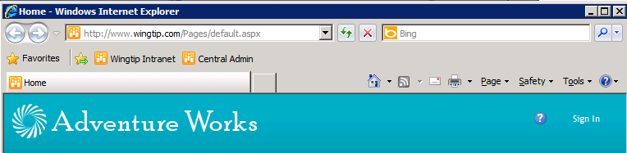

1. Click the **Sign in** link. The browser should then log you in transparently using the current Windows user account which is **WINGTIP\Administrator**.

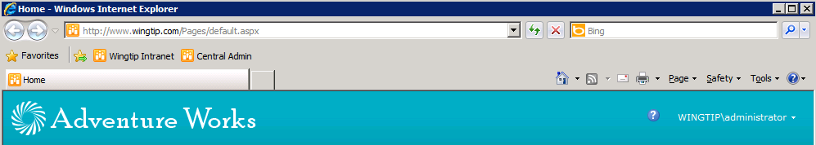

1. Once the browser has logged you on using a Windows account, you must go through the following steps to access the site again using anonymous access.
2. Close all open instances of the Internet Explorer.
   1. Click **Start » Run**.
3. Type in the URL of [**http://www.wingtip.com**](http://www.wingtip.com) and click **OK**.

You are now finished. You have created one Web application using Classic Mode and a second Web application using Claims-based Authentication. You also learned how to configure anonymous access for an Internet-facing site.